1000_PTR Enrollment initiated by EV for an Single customer Electric Meter
Contract No. 4015028196
Material No. 88000104
Serial No. 20003310
Equipment No. 100004737022
Contract Account. 100052293196
Functional Location. 6001236048
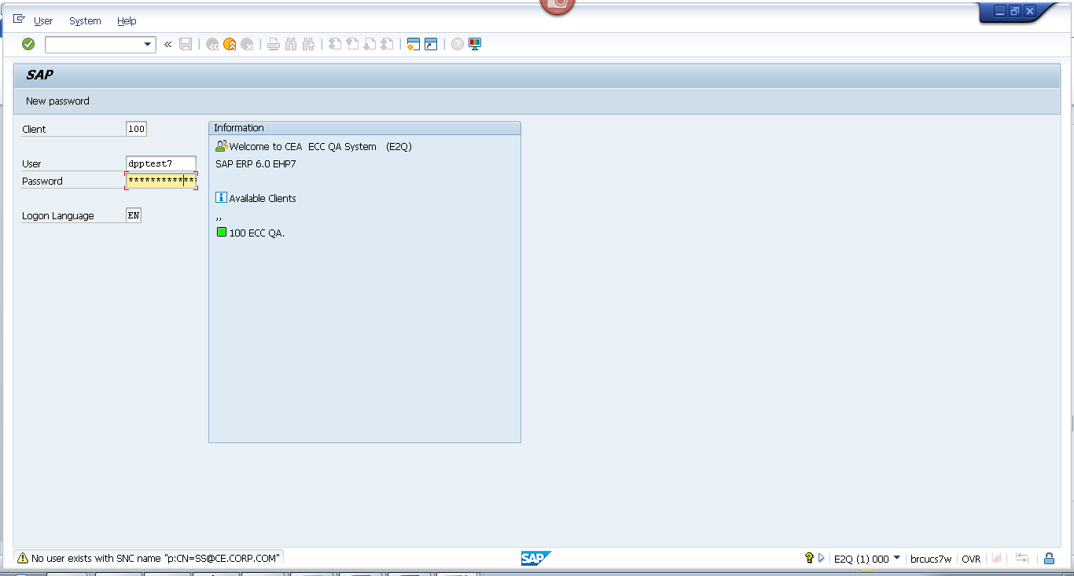
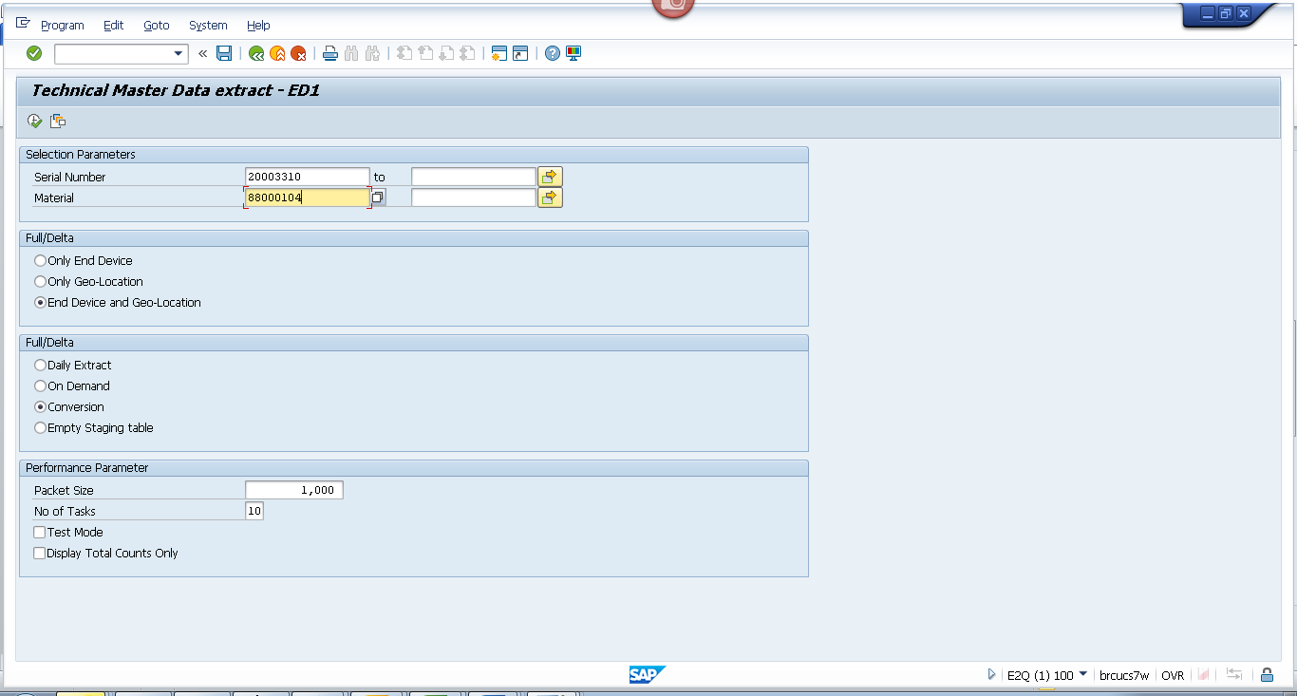
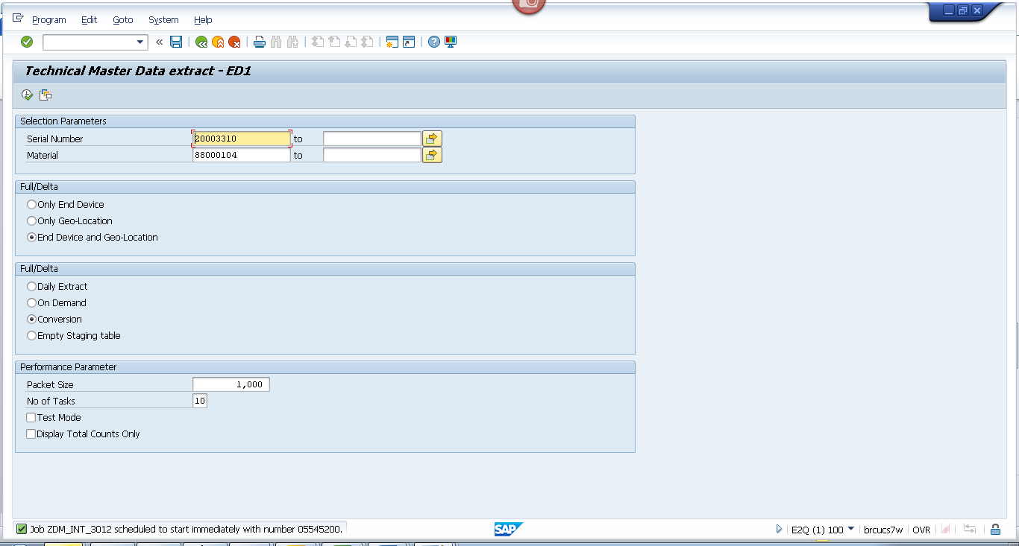
Obj tracking
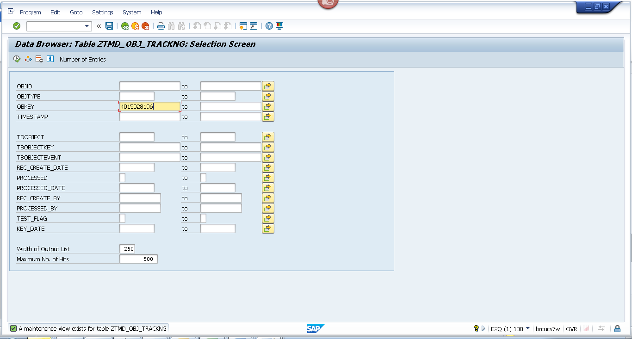
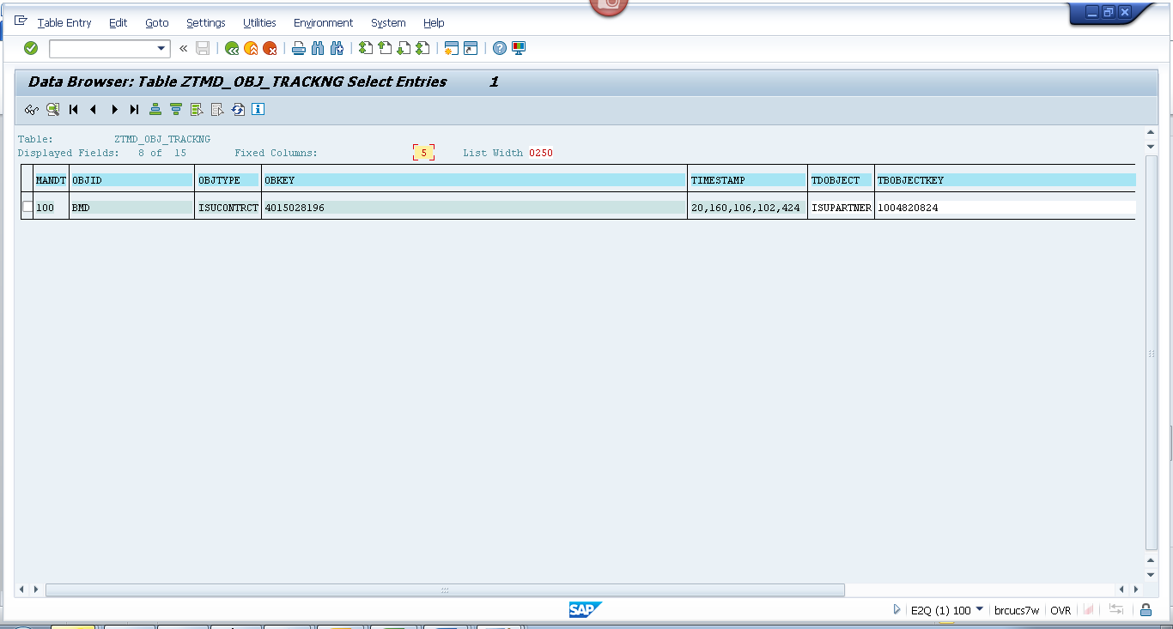
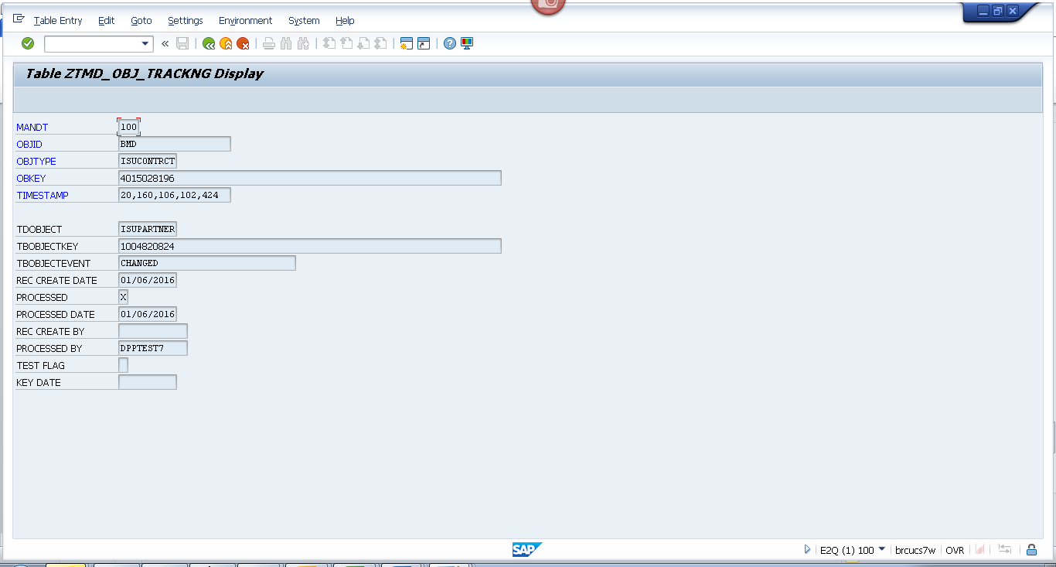
Spool
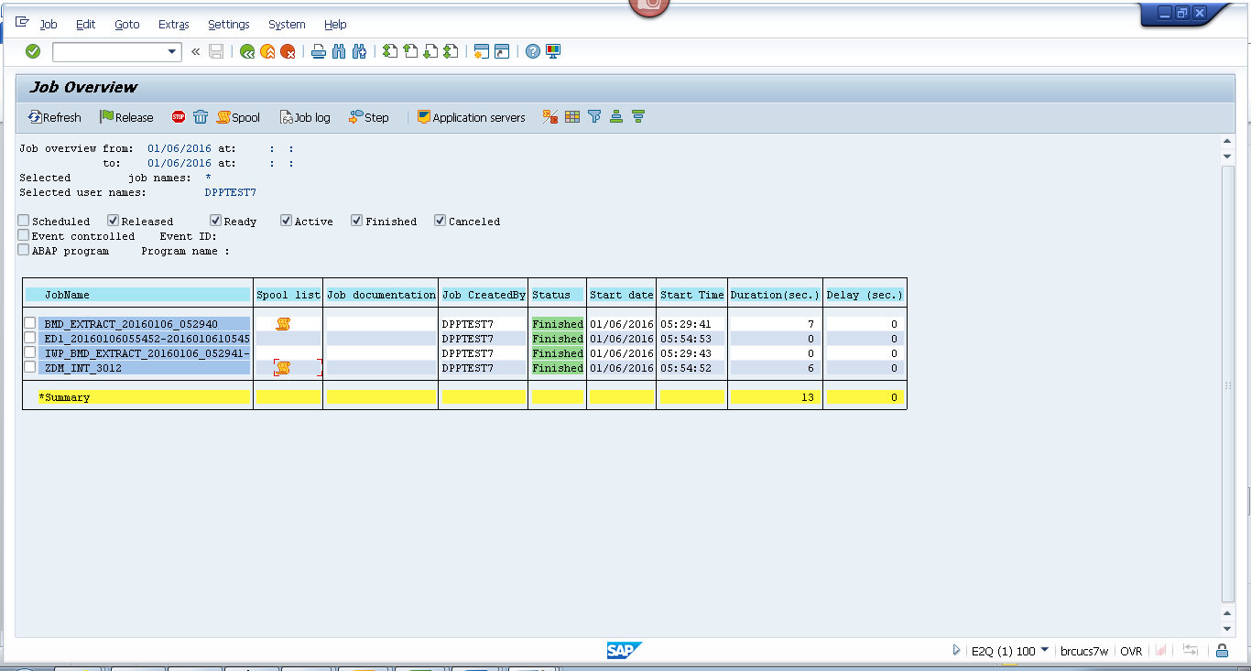
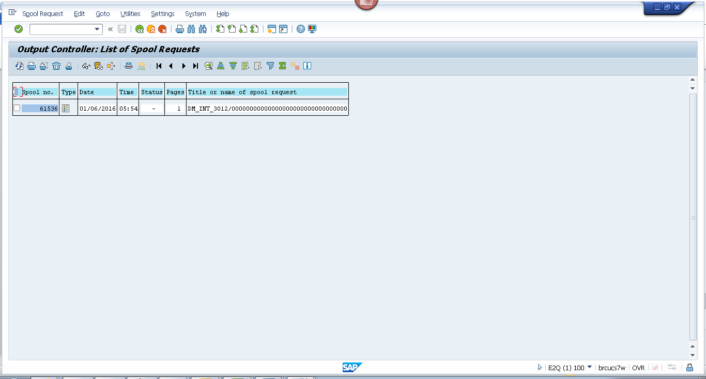
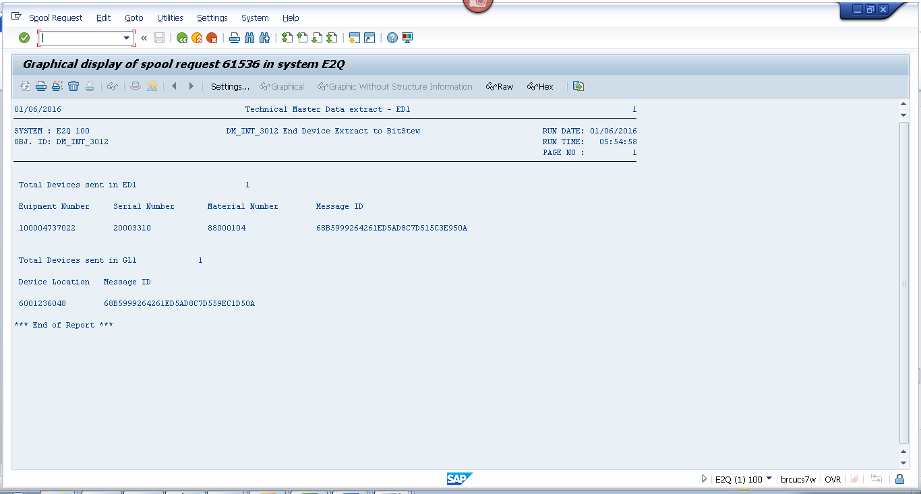
Payload
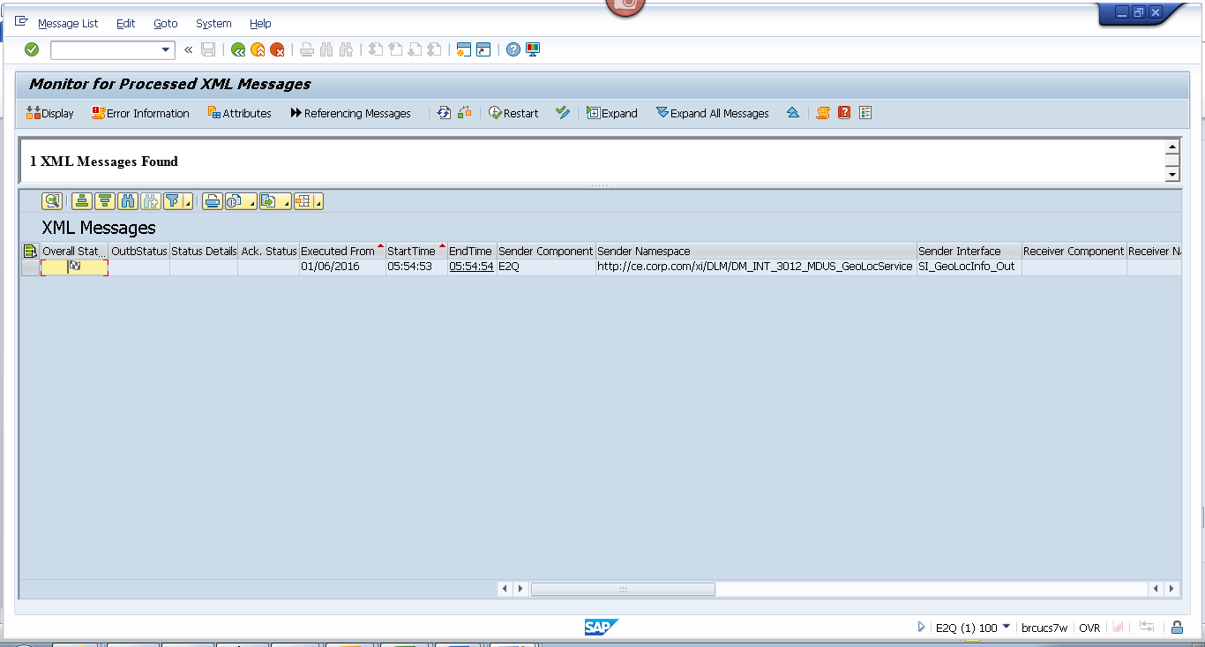
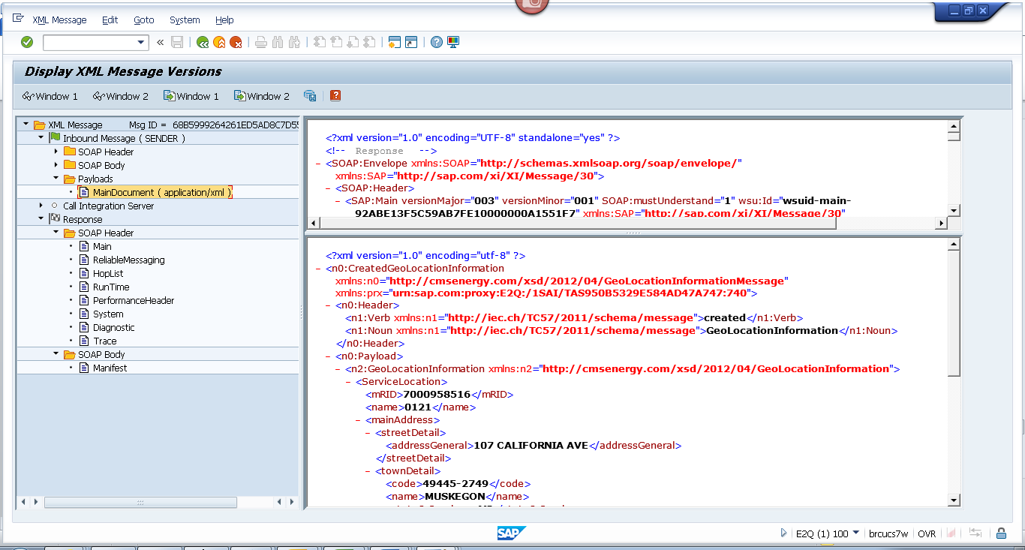
Geo loc
<?xml version="1.0" encoding="utf-8" ?>
- <n0:CreatedGeoLocationInformation xmlns:n0="http://cmsenergy.com/xsd/2012/04/GeoLocationInformationMessage" xmlns:prx="urn:sap.com:proxy:E2Q:/1SAI/TAS950B5329E584AD47A747:740">
- <n0:Header>
<n1:Verb xmlns:n1="http://iec.ch/TC57/2011/schema/message">created</n1:Verb>
<n1:Noun xmlns:n1="http://iec.ch/TC57/2011/schema/message">GeoLocationInformation</n1:Noun>
</n0:Header>
- <n0:Payload>
- <n2:GeoLocationInformation xmlns:n2="http://cmsenergy.com/xsd/2012/04/GeoLocationInformation">
- <ServiceLocation>
<mRID>7000958516</mRID>
<name>0121</name>
- <mainAddress>
- <streetDetail>
<addressGeneral>107 CALIFORNIA AVE</addressGeneral>
</streetDetail>
- <townDetail>
<code>49445-2749</code>
<name>MUSKEGON</name>
<stateOrProvince>MI</stateOrProvince>
</townDetail>
</mainAddress>
- <UsagePoints>
<mRID>6001236048</mRID>
<name>OUT LEFT</name>
- <EndDevices>
<mRID>CA-61-10172322-0111</mRID>
<type>T</type>
</EndDevices>
- <PositionPoint>
<xPosition>-86.236048</xPosition>
<yPosition>43.236048</yPosition>
</PositionPoint>
</UsagePoints>
</ServiceLocation>
</n2:GeoLocationInformation>
</n0:Payload>
</n0:CreatedGeoLocationInformation
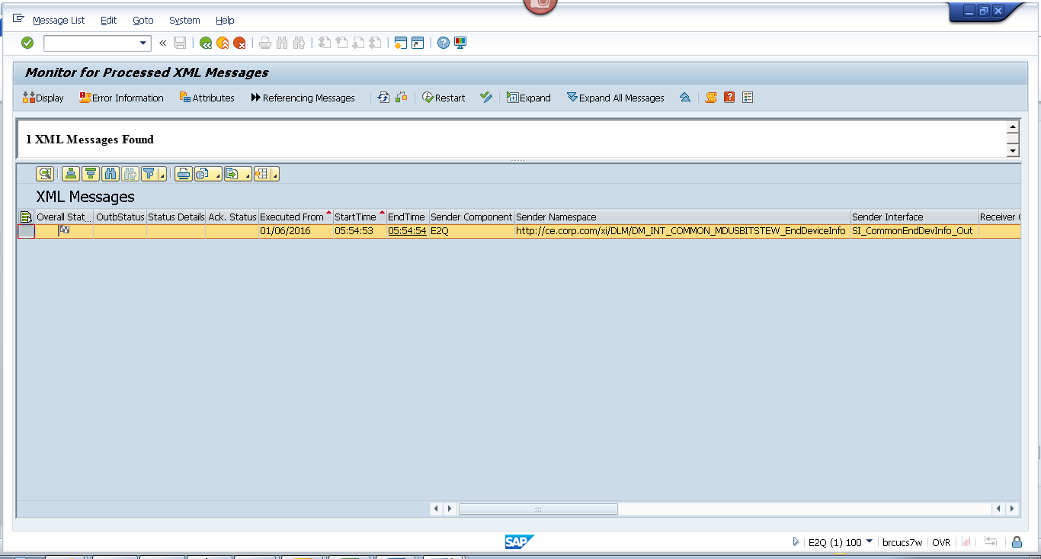
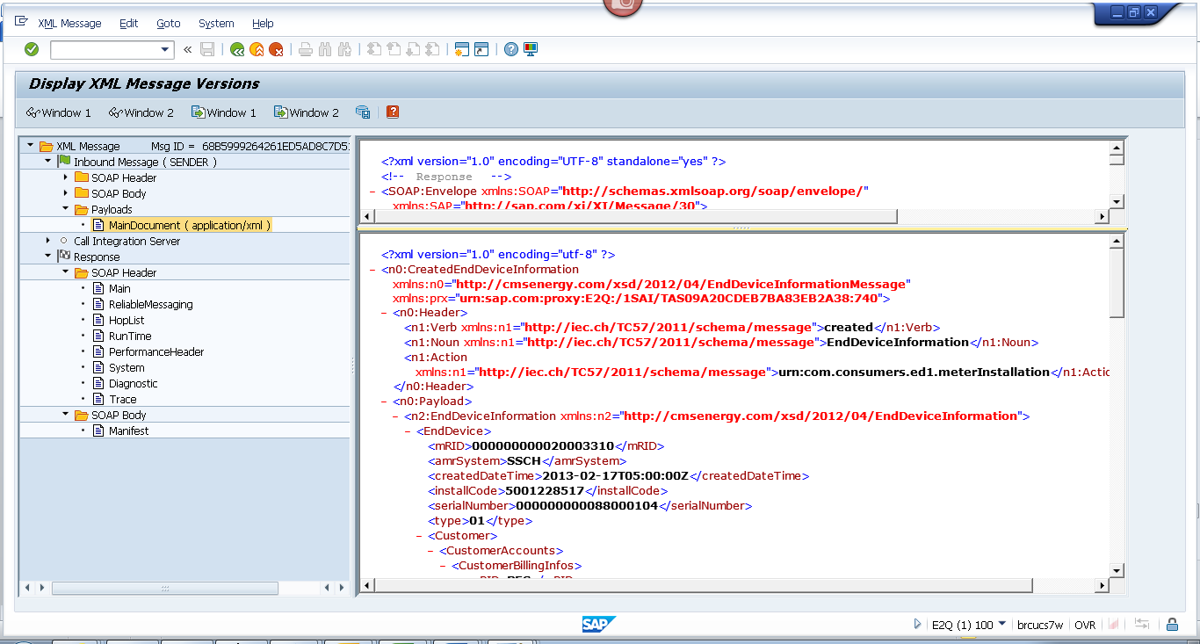
End device
<?xml version="1.0" encoding="utf-8" ?>
- <n0:CreatedEndDeviceInformation xmlns:n0="http://cmsenergy.com/xsd/2012/04/EndDeviceInformationMessage" xmlns:prx="urn:sap.com:proxy:E2Q:/1SAI/TAS09A20CDEB7BA83EB2A38:740">
- <n0:Header>
<n1:Verb xmlns:n1="http://iec.ch/TC57/2011/schema/message">created</n1:Verb>
<n1:Noun xmlns:n1="http://iec.ch/TC57/2011/schema/message">EndDeviceInformation</n1:Noun>
<n1:Action xmlns:n1="http://iec.ch/TC57/2011/schema/message">urn:com.consumers.ed1.meterInstallation</n1:Action>
</n0:Header>
- <n0:Payload>
- <n2:EndDeviceInformation xmlns:n2="http://cmsenergy.com/xsd/2012/04/EndDeviceInformation">
- <EndDevice>
<mRID>000000000020003310</mRID>
<amrSystem>SSCH</amrSystem>
<createdDateTime>2013-02-17T05:00:00Z</createdDateTime>
<installCode>5001228517</installCode>
<serialNumber>000000000088000104</serialNumber>
<type>01</type>
- <Customer>
- <CustomerAccounts>
- <CustomerBillingInfos>
<mRID>RES</mRID>
<type>A_200</type>
<startDate>1900-01-01T05:00:00Z</startDate>
<endDate>2008-11-24T05:00:00Z</endDate>
<readRoute>041923</readRoute>
<readCycle>19</readCycle>
</CustomerBillingInfos>
- <CustomerBillingInfos>
<mRID>RES</mRID>
<type>RS_1000</type>
<startDate>2008-11-25T05:00:00Z</startDate>
<endDate>9999-12-31T05:00:00Z</endDate>
<readRoute>041923</readRoute>
<readCycle>19</readCycle>
</CustomerBillingInfos>
</CustomerAccounts>
</Customer>
- <EndDeviceFunction>
<mRID>000000100004737022</mRID>
<name>ESM 1PH 3W 200A 240V 2S SS RS/RT</name>
<programID>1NDRSRT001</programID>
</EndDeviceFunction>
- <UsagePoint>
<mRID>6001236048</mRID>
<name>OUT LEFT</name>
<phaseCode>A</phaseCode>
<readCycle>19</readCycle>
<readRoute>041923</readRoute>
- <Installation>
<mRID>5001228517</mRID>
</Installation>
- <MeterServiceWorks>
<type>MIV</type>
</MeterServiceWorks>
- <ServiceLocation>
<mRID>7000958516</mRID>
<name>0121</name>
- <mainAddress>
- <streetDetail>
<addressGeneral>107 CALIFORNIA AVE</addressGeneral>
</streetDetail>
- <townDetail>
<code>49445-2749</code>
<name>MUSKEGON</name>
<stateOrProvince>MI</stateOrProvince>
</townDetail>
</mainAddress>
</ServiceLocation>
</UsagePoint>
- <information>
<description>1002</description>
<title>AMCG</title>
</information>
- <status>
<reason>System Status</reason>
<value>Installed</value>
</status>
- <status>
<reason>User Status</reason>
<value>No Special test Available</value>
</status>
- <status>
<dateTime>2012-12-16T05:00:00Z</dateTime>
<reason>Cutover Date</reason>
</status>
- <status>
<dateTime>2012-12-15T05:00:00Z</dateTime>
<value>Install Date</value>
</status>
- <status>
<reason>Certification Year</reason>
<value>2012</value>
</status>
- <status>
<reason>Certification Status</reason>
<value>No restriction</value>
</status>
</EndDevice>
</n2:EndDeviceInformation>
</n0:Payload>
</n0:CreatedEndDeviceInformation>

